All-Wales Operational Document
Deactivation of Implantable Cardioverter Defibrillators (ICD) at the end of life

Version 4
February 2019

All-Wales Operational Document for
Deactivation of Implantable Cardioverter Defibrillators (ICD) at the end of life

ICDs are used to treat life threatening heart rhythms and help reduce the risk of sudden death caused by ventricular tachycardia or ventricular fibrillation. The ICD works by delivering an electrical charge or by rapid pacing of the myocardium when it senses either ventricular tachycardia or ventricular fibrillation. This charge shocks the heart, which then allows for a normal heart rhythm to be resumed. Nowadays, many patients with an ICD have additional capability features to deliver cardiac resynchronisation pacing therapy (CRT) to improve symptoms of heart failure

Many patients with ICDs in situ are able to enjoy a prolonged life expectancy with a reasonable quality of life. However in patients who have progressive cardiac failure or other co-morbid conditions, the shocks from the device or even the thought of the device shocking can cause physical suffering and severe anxiety. When terminal illnesses such as cancer are diagnosed or advanced stages of a long term condition such as heart / renal failure or dementia patients may find the additional stress of anticipating an ICD shock an unnecessary burden, particularly as the outcome will have no impact on the underlying condition. Furthermore the incidence of arrhythmias may increase with the development of electrolyte imbalance, hypoxia and pain, potentially leading to an increase in shock therapy. Shock therapy, whether single or multiple discharges are not conducive to a peaceful death. For these patients the option of deactivating the device can be a sound medical, ethical and legal decision.

Indications for Considering Deactivation (as used by the Arrhythmia Alliance)¹

• Patient preference in advanced disease
• Imminent death (activation inappropriate in the dying phase)
• While an active DNR (Do Not Resuscitate) order is in force
• Withdrawal of anti-arrhythmic medications

Explaining ICD Deactivation to patients and carers

The discussion regarding deactivation should be an open discussion between patient, their family and a health care professional, eg GP, Palliative or cardiology team. It is important that efforts are made to ensure that the discussion takes place whilst the patient is still able to be involved in the decision making process. The patient needs to be made aware of the benefits and harms of deactivating the device.

In patients where it is clear that device deactivation in the future is likely, it is appropriate to consider discussion of this option with the patient and their carer, well in advance of a decision on deactivation being required. In fact, many ICD services discuss the possibility of device deactivation in the future with ICD patients at the time of initial device implantation.

Whenever discussions about deactivation are undertaken, the patient and carers should be made aware that by deactivating the ICD the device will no longer provide therapies in the event of life threatening arrhythmias, thereby allowing a natural death.
Turning off the device is not a painful procedure and will only take a matter of seconds to complete.

It is important to try and avoid last minute decisions, not only to avoid unnecessary distress but also as it can be difficult to arrange device deactivation out of hours. Within normal working hours either contact the consultant cardiologist responsible for follow-up of the patient, the arrhythmia specialist nurse or the cardiac physiology department that implanted the device to arrange device deactivation.

Important points to explain to people about ICD deactivation²

- Near the end of your life your ICD may deliver shocks that are painful and distressing and are of no benefit.
- Deactivating your ICD will not cause death.
- Once your ICD has been deactivated, if you have a heart rhythm change that could cause death, your ICD will not deliver treatment for it.
- Deactivating the shock function of your ICD does not deactivate its pacemaker function.
- Deactivating your ICD will be painless.
- If your condition improves unexpectedly or you change your mind the ICD can be reactivated.
- It is best to think & decide about ICD deactivation in advance, rather than in a crisis.

Arrhythmia CNS contact details
The appropriate Arrhythmia CNS contact details should be held by all ICD recipients.

South East Wales
Cardiff and Vale, Aneurin Bevan) 029 2074 4486

South Wales
Cwm Taf – south) 01443 443443 ext 6486
Cwn Taf – north) 01685 726945

South West Wales
ABMU, Hywel Dda) 01792 618843

North Wales
Ysbyty Gwynedd 01248 385376
Glan Clwyd 01745 445506
Wrexham Maelor 01978 725949

Cardiac physiology department contact details:

South East Wales
Royal Gwent Hospital 01633 234299
UHW 029 2074 3325

South Wales
Royal Glamorgan 01443 443443 ext 6362

Mid & West Wales
Morriston Hospital 01792 618849
Bronglais Hospital 01970 635747
Prince Philip Hospital 01554 783157
Withybush Hospital

North Wales
Ysbyty Gwynedd 01248 384058
Glan Clwyd 01745 448367
Wrexham 01978 725275

There is no out-of-hours cardiac physiology service for ICD patients.

If the decision is made out of hours or in an emergency situation where immediate action is necessary, a magnet can be placed in contact with the skin directly over the device (figure 1). The device normally lies in the left infraclavicular region and should be visible and palpable under the skin. The magnet causes the device shock therapies to become deactivated, but only whilst the magnet is in place. The magnet suspends tachyarrhythmia detection and shock therapy but does not affect the device functioning as a pacemaker or cardiac resynchronisation therapy pacemaker (CRT). The magnet should be taped in position with a strong adhesive tape (e.g. sleek) until alternative deactivation can be arranged.
In some ICDs (e.g.Biotronik) magnet inhibition is limited to a maximum of 8 hours. Therefore, as patients will not always know the make of their ICD, the magnet should always be removed (for a few seconds) then replaced, every 7 hours until it is deactivated by a cardiac physiologist. Application of a magnet does not guarantee device inactivation. Under certain circumstances (such as when the device is deeply buried) magnet application may be ineffective. Device deactivation with a programmer should always be arranged at the earliest opportunity.
If a patient is very near death when the decision is made it may be appropriate to continue using the magnet for device deactivation until after death. It is then safe, following verification of death, for healthcare professionals to remove the magnet and follow post-death procedures as they would for any other patient.

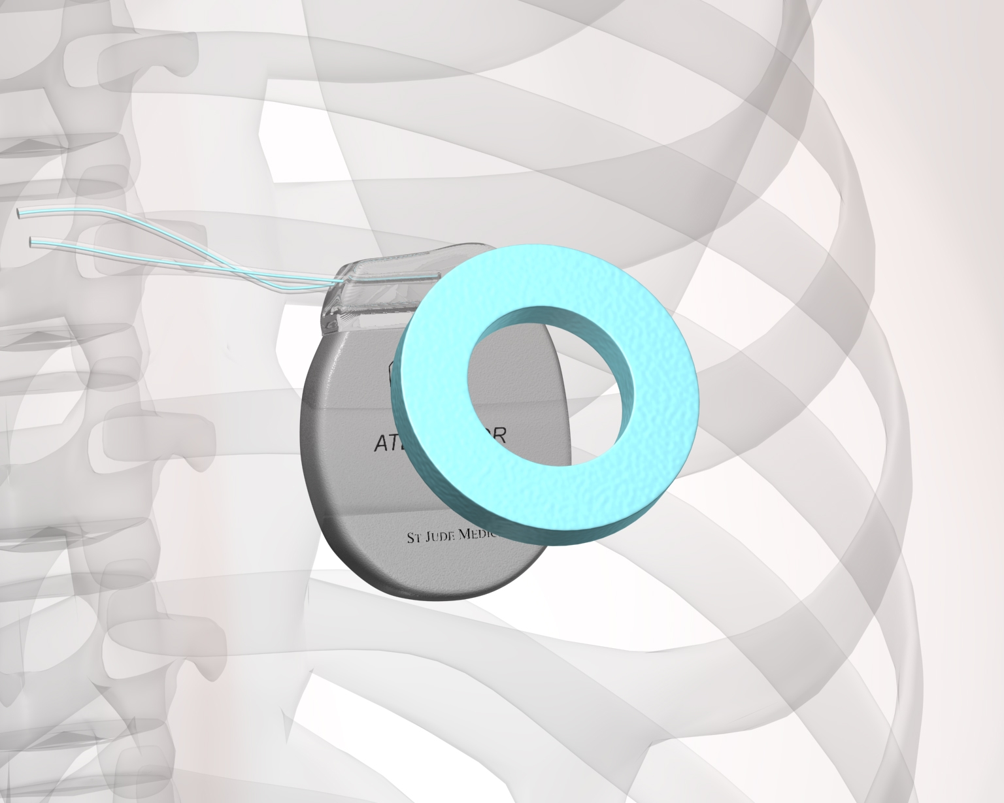 | 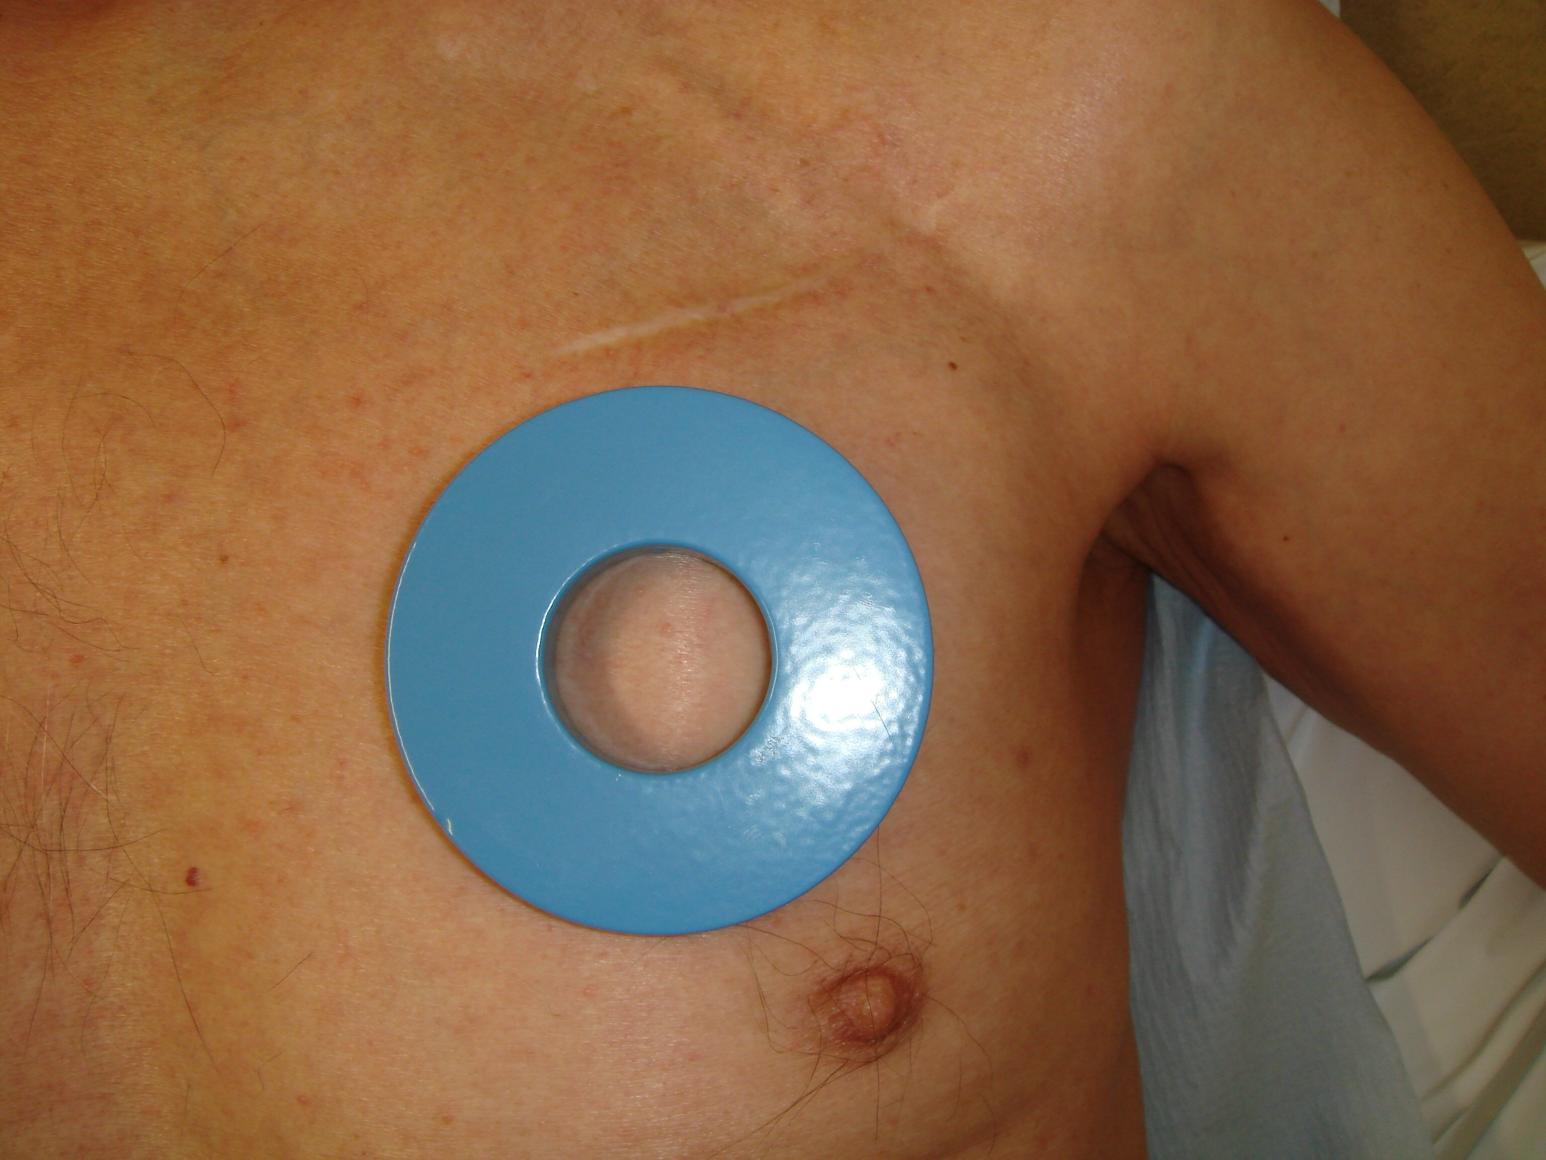
Fig 1. Placement of the magnet over the chest (directly overlying the ICD). The magnet should be secured in place with strong adhesive tape such as sleek.
Images reproduced with kind permission of ABMUHB and NHS Wales.

A magnet for this purpose is available from:.............................................................
To access it out of hours you should contact:...........................................................

The electrical activity of in situ ICDs can be monitored remotely by the patient’s ICD team, it is therefore important to inform the cardiology team if you have deactivated the device with a magnet.

It is safe for healthcare professionals, relatives and carers to be in contact with patients who have an ICD in situ. If an individual had skin-to-skin contact with the patient at the time an ICD was to deliver a shock they may feel a tingling sensation but this does not pose a health risk.³

Care of ICDs after death

It is good practice to inform the ICD team responsible for the patient’s follow-up of their death if they are not already aware. Relatives should be made aware that cremation is not possible with an ICD in situ. If the device was permanently deactivated prior to death, and the patient is for cremation, mortuary or undertaker staff must be informed as the device will need to be removed.

If the device had not been deactivated prior to death, or was only temporarily deactivated with a magnet, then the device will first need to be deactivated prior to removal by mortuary or undertaker staff, otherwise they are at risk of receiving a shock. Contact the ICD team for guidance in regards disposal of the device after removal²

If the patient is for burial it is not usually necessary for the device to be deactivated or removed however it is still recommended that you liaise with the ICD team to confirm that they do not need to examine the device.

Ethical and Legal issues

To ensure that legal and ethical issues are considered, the patient must be fully informed of their options. A patient’s right to request withdrawal of life sustaining medical interventions, including ICDs, is both legal and ethical. Where treatment may only prolong the dying process or cause unnecessary distress the burdens and risks may outweigh the benefits of treatment.⁴

If the patient lacks capacity to make a decision and the patient has not made any legally binding advance decision and nobody else holds legal authority to decide on treatment withdrawal (lasting power of attorney), then the clinician with responsibility for the patient’s care has a duty to act in the patient’s best interests.⁵ In such situations, the clinician will discuss with the family and those close to the patient and if there are no such people, take the advice of an independent mental capacity advocate (IMCA) before making such decisions. The exception would be an emergency situation where the patient was distressed.

The treating clinician should document all discussions and decisions relating to ICD deactivation in the patient’s case notes. A recommended format for documenting these decisions (adapted from the Arrhythmia Alliance) is included in the appendix of this document.

Support

It is advisable that training and support is available for clinical staff, such as cardiac physiologist, involved in the discussion and deactivation process.

Acknowledgements

These guidelines have been adapted, with kind permission, from the South East Wales Cardiac Network Guidelines: Cardiac Arrest Survivors and Implantable Defibrillator Recipients: Implementation of the Recommendations contained in Standard 5 of the Cardiac National Service Framework. January 2011.

References
- Arrhythmia Alliance. Implantable Cardioverter Defibrillaros (ICDs) in Dying Patients. [Accessed 31st January 2011] Available at: http://www.hruk.org.uk/Docs/ICD%20Deactivation%20Leaflet-Arrhythmia%20Alliance.pdf

- Resuscitation Council (UK). Cardiovascular implanted electronic devices in people towards the end of life, during cardiopulmonary resuscitation and after death. Published March 2015

- Stevenson WG Chaitman BR Ellenbogen KA et al. Clinical Assessment and Management of Patients with Implantable Cardioverter-Defibrillators Presenting to Nonelectrophysiologists. Circulation. 2004; 110:3866-3869.

- General Medical Council. Treatment and care towards the end of life: good practice in decision making. July 2010. Paragraph 3.

- General Medical Council. Treatment and care towards the end of life: good practice in decision making. July 2010. Paragraph 15.

- National Institute for Health and Care Excellence. Implantable cardioverter defibrillators and cardiac resynchronisation therapy for arrhythmias and heart failure (review of TA95 and TA120). London: NICE, 2014. Available from: http://guidance.nice.org.uk/ta314

Appendix I
Deactivation of Implantable Cardioverter Defibrillator

Patient’s Name:……………………………………………………………………….............

Address:……………………………………………………………………………….............
………………………………………………………………………………………….............
…………………………………………………………Date of Birth..................................
GP Details:……………………………………………………………………………............

Date/Time of Request:………………………………………………………………............

Address patient is currently located at:……………………Phone No:........….................

Reason for request: eg terminal cancer or advanced dementia ...............................…………………………………………………………………............
…………………………………………………………………………………………............
To be signed either by the patient or treating clinican. If patient lacks capacity to consent, the decision should be discussed with the next-of-kin/carers/relatives and a best interest decision should be made by the treating clinician.

I understand the reasons for deactivating my ICD and that the decision to deactivate can be reviewed if necessary. I agree to the deactivation of my ICD.

Signature of patient:………………………………...............Date: ....................................

Signature of treating clinician (GP/Consultant/Registrar):…..……………......................

To be completed by ICD team:

Date and time device deactivated:…………………………………………………………..

Location deactivated e.g. clinic, ward, home, hospice:…………………………………...

Any treatments that remain active:………………………………………………….. ..........

Any other comments:....................................................................................................

Signature of ICD consultant:.................................................................Date:...............

Signature of professional deactivating the device:.........................................................

