Laboratory Information Network Cymru Programme
(LINC)

Vision Statement

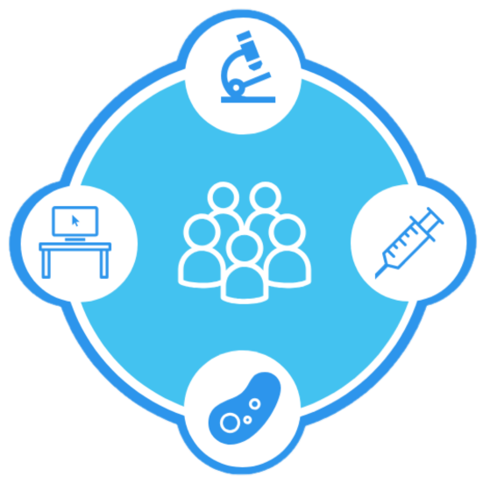

Document Control
Document Information:
Document Name: | Vision Statement
Version: | 1.0
Date Issued: | 10 February 2020
Status: | Draft
Document Owner: | Adrian Thomas
Document Author: | Judith Bates
Contributor(s):
Document History:
Amended by | Version | Status | Date | Purpose of Change
Judith Bates | 0.1 | Draft | 19-Jan-20 | Create document
Judith Bates | 0.2 | Draft | 10-Feb-20 | LDA comments
Sam Stephens | 1.0 | Final | 18/02/2021 | Final version

Circulation List:
Name | Title | Organisation
LINC Programme Board
LINC PMO
LINC newsletter

Purpose
The purpose of this vision statement is to provide a summary of a better future; the desired future state following programme delivery. It describes how pathology services will have improved because of the investment being made and be used a basis for the blueprint and benefits. It is important to be able to explain the vision in a way that all stakeholders can readily understand, sign up to and be able to repeat. As such, it needs to be short and memorable.
The vision statement is presented as a draft for discussion at the LINC Design Authority being held on 22 January 2020.

LINC Conference: the Future of Pathology
At the LINC Conference: The Future of Pathology, held on 7 October 2019, participants were asked to consider their vision for the service. These are presented in Appendix 1 and used as a basis for defining the draft vision statement below.

Vision Statement
The pathology services across Wales work in unison to provide a patient-focused and clinically-led service, with managerial support, enabling the best care, pathways and outcomes for patients. A resilient, motivated and valued workforce achieve operational excellence though training and engagement of staff at all levels.
The pathology service is standardised, sustainable and prudent. People, process and technology are integrated to provide secure, stable and lean services at health board, regional or national levels. With patient safety and quality at its core, accreditation and validation are readily achieved.
The pathology service is supported by end-to-end systems and processes including electronic test requesting, laboratory information management system (LIMS) services, results reporting, alerts and notifications, underpinned by an open technical platform and integration services. Demand management ensures test requesting is clinically justified. Results are securely available across Wales to all clinicians at any location.
A single, national, standardised and validated LIMS service for all disciplines provides a highly resilient, safe and easy to use system that seamlessly underpins all Wales standardised, operational services. Business intelligence provides comparable data to manage and performance monitor the service as a basis for continuous improvement.
The Pathology service is future proofed, able to evolve and respond to future developments in work patterns and practices, new technology and innovation.

Appendix 1: Vision Statements suggested at the LINC conference October 2019
Our pathology service is clinically led to meet the needs of service users eith patient safety and quality at its centre. It is standardised, reliable and prudent with the ability to respond to future developments. It is fully integrated, stable, lean and, and can be delivered at health board, regional or national level.

Proactive, responsive, fully supported, sustainable, patient-centred, prudent, quality, delivered at health board, regional and national level.

S – successful, stable
T – transformational
A – accredited
F – focused (patient)
F – future, flexible
P – productive
A – accredited
T- transformational
I – integrated
E – evolving
N – national
T – team
S – safe
Live, life, love, LIMS

- To provide the best diagnosis and prognosis for the patients under our care.
- A strong, resilient workforce making the right decision at the right time for the right patient
- Future proofing with the development of agile systems / services moving seamlessly whilst speaking supporting all care pathways

- Stability and speed
- Nationally test one with end-to-end testing
- Retain some flexibility with new innovations
- Engagement of everybody at every level / multi-discipline
- Removal of unwarranted variation
- Support and training
- User friendly
- Live dashboard
- Fully auditable

- Seamless, evolving
- End-to-end solution for Wales, which gies:
  - Value for money, and
  - Comparable data
  - Adopting best practice
- BI – fir for purpose, user friendly, robust
- No unwarranted data
- ETR fit for purpose
- 1º/2º infrastructure
- Connect disciplines, so results available nationally at any location not boundary specific
- Evolve
- Incorporate new technology, new work patterns, practices
- Portable devices

- 100% e-requesting on a single system (best chance of reducing errors)
- Best standardised service possible
- 100% uptime
- Single system to rule them all
- Excellent change control

